Name – Harshad Khedekar
Email – harshadkhedekar123@gmail.com

1. How many types of conditions are available in conditional formatting on Excel?
- For Multiple conditions
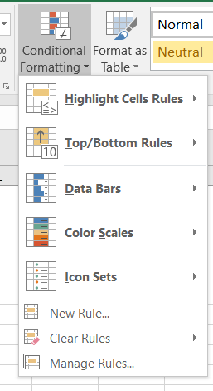
- There are 5 types of conditional formatting visualizations available:
- Background Color Shading (of cells)
- Foreground Color Shading (of fonts)
- Data Bars
- Icons (which have 4 different image types)
- Values

2. How to insert border in Excel with Format Cells dialog?
To insert a border via the Format Cells dialog, this is what you need to do:
- Select one or more cells to which you'd like to add borders.
- Open the Format Cells dialog box by doing one of the following:
- Click the down arrow next to the Borders button, and then click More Borders at the bottom of the drop-down list.
- Right click the selected cells and choose Format Cells… from the context menu.
- Press Ctrl+1 shortcut.
- In the Format Cells dialog box, switch to the Border tab and choose the line style and color first. And then, either use Presets to add the outside or inside borders or construct the desired border by selecting individual elements such as border top, bottom, right or left. The preview diagram will reflect the changes immediately.
- When done, click OK.
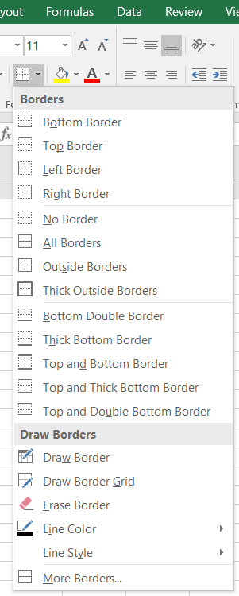
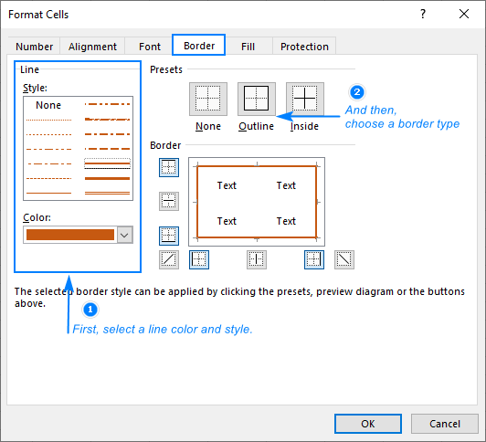

3. How to Format Numbers as Currency in Excel?
To show numbers as currency, you can apply either the Currency format or the Accounting format.
- Select the cells that you want to format and then, in the Number group on the Home tab, click the down arrow in the Number Format box.
- Choose either Currency or Accounting.
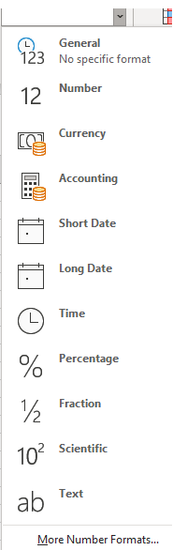
- Number format drop-down screen
- Excel for the web applies the default currency symbol and appropriate decimal places in the cells that you selected.

4. What are the steps to format numbers in Excel with the Percent style?
To quickly apply percentage formatting to selected cells, click Percent Style Button image in the Number group on the Home tab, or press Ctrl+Shift+%. If you want more control over the format, or you want to change other aspects of formatting for your selection, you can follow these steps.
- On the Home tab, in the Number group, click the icon next to Number to display the Format Cells dialog box.
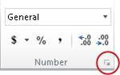
- In the Format Cells dialog box, in the Category list, click Percentage.
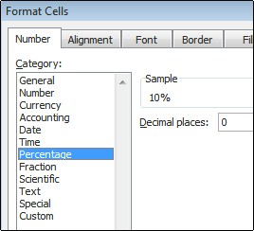
- In the Decimal places box, enter the number of decimal places that you want to display. For example, if you want to see 10% instead of 10.00%, enter 0 in the Decimal places box.

5. What is a shortcut to merge two or more cells in excel?
- Merge Cells: ALT H+M+M
- Merge & Center: ALT H+M+C
- Merge Across: ALT H+M+A
- Unmerge Cells: ALT H+M+U

6. How do you use text commands in Excel?
- Syntax = TEXT(value, format_text)
Value - A numeric value that you want to be converted into text.
Format text- A text string that defines the formatting that you want to be applied to the supplied value.
- The TEXT function lets you change the way a number appears by applying formatting to it with format codes. It's useful in situations where you want to display numbers in a more readable format, or you want to combine numbers with text or symbols.

